The Automated Handwashing Station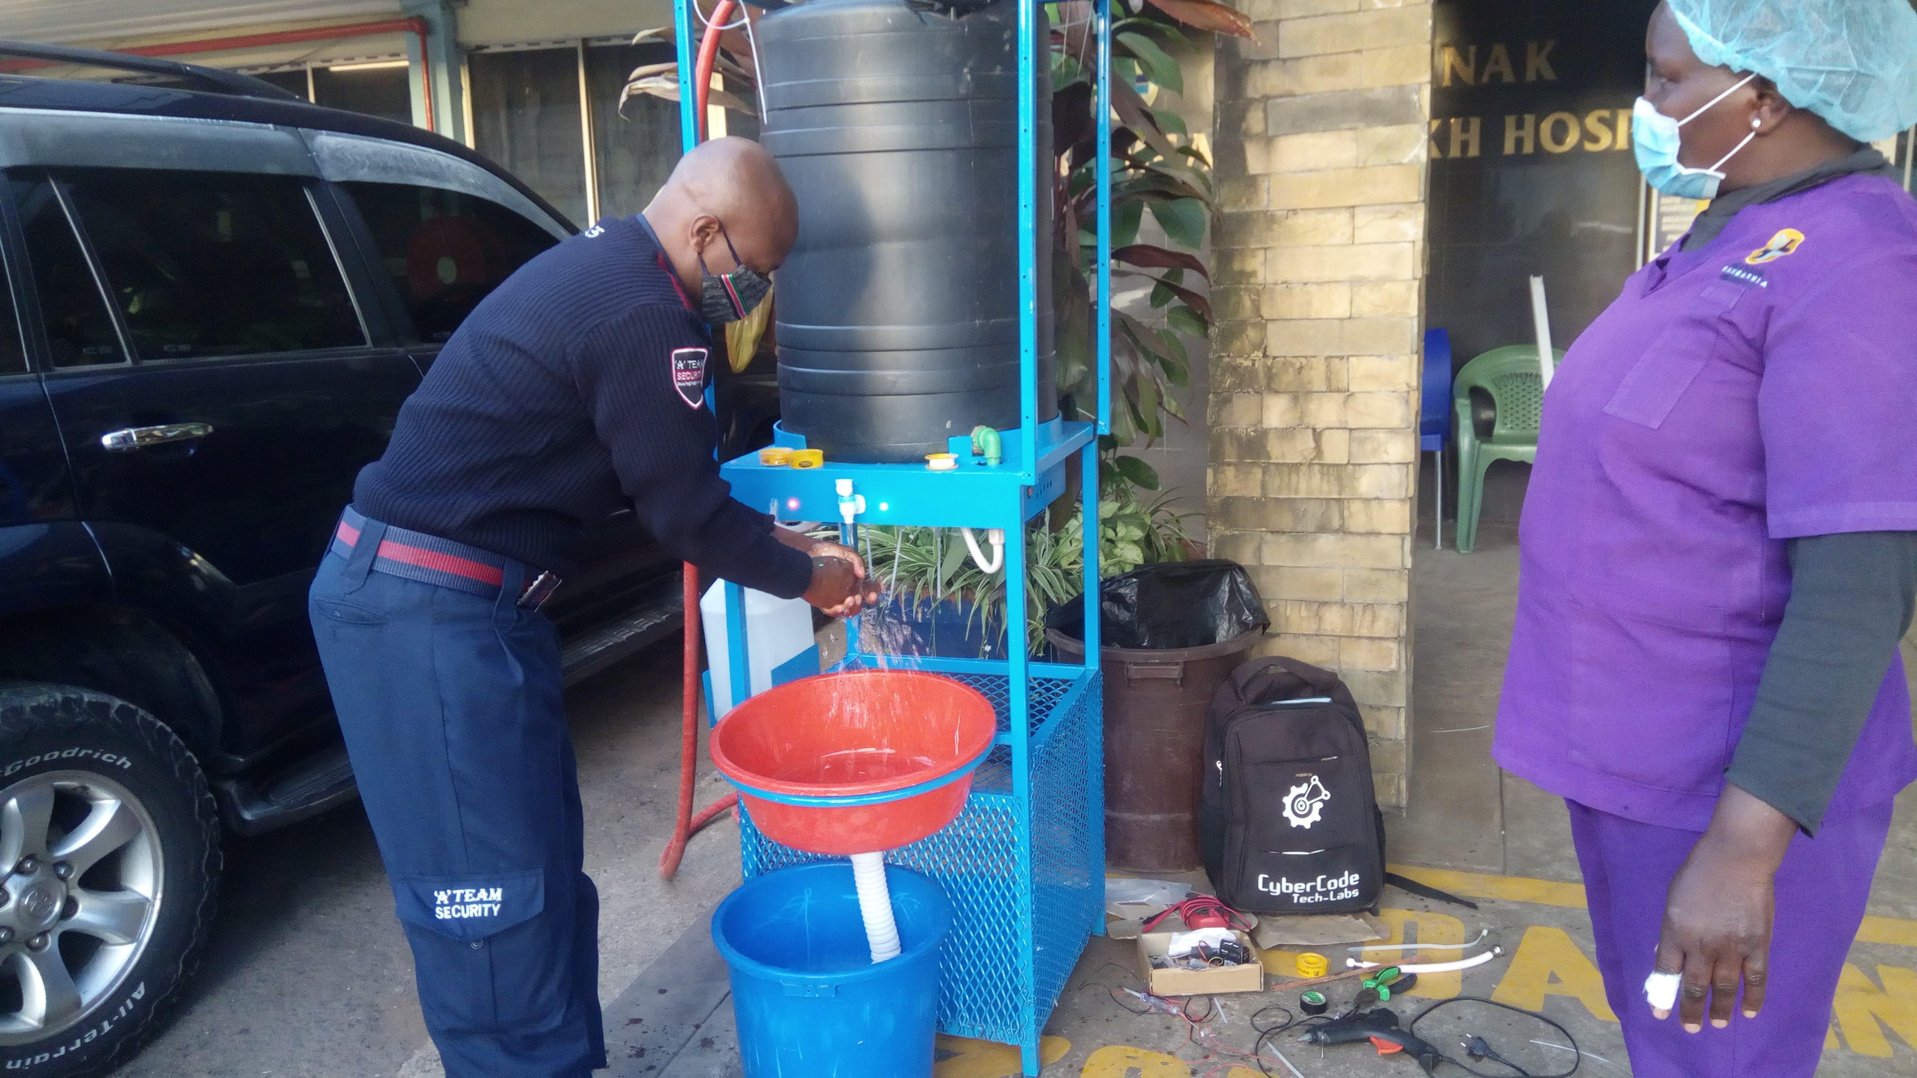

Hand-washing should be a routine. This is key especially with the outbreak of Covid-19 in Kenya and the world.

Recommendation from the WHO

1. **Wash your hands frequently.**
2. Maintain social distancing.
3. Avoid touching your face, practise respiratory hygiene.

We built the hand-washing station to reduce the spread of the virus at areas with high traffic. Our station is unique and has the following features:

**Features**

* Double sided- Can accommodate more users at the same time, **reducing queuing** at your place of business.
* **No contact**- Users do not touch anything with their hands, reducing risk.
* Is **an advertising tool**- Promote your business at one of the most trafficked point of your establishment.
* Maintain **a clean environment** by having users dispose off their waste safely

**Quality**

The station is built to last. that is why quality is key. We offer the best quality the market has to offer. Our products are built to last. **What next after Covid-19?** We will still maintain our new found ‘habit’ of washing our hands, constantly. We make it possible for you to use the product long after the pandemic

**Affordability**

We ensure you get the best value for money in that we use the best quality materials the market has to offer. This is what makes our Solution different.

REBRANDING BINS AT MULTIMEDIA UNIVERSITY

Bins at Multimedia University were old, spoilt and generally looked worn out. We wanted to repaoir them and rebrand them so they can be more appealing to use.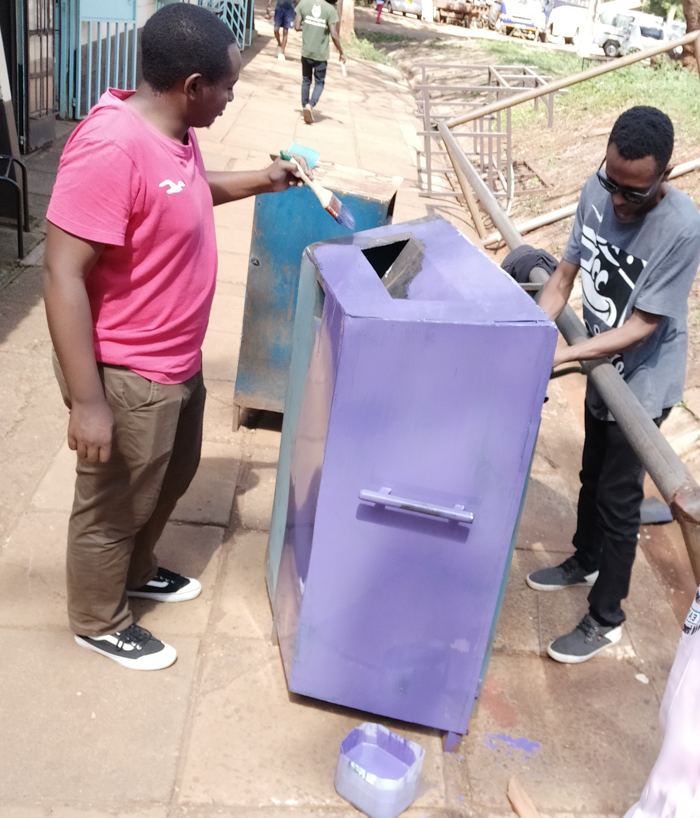

Step 1: Repairing the bins

Step 2: Rebranding

Step 3: Re-positioning bins to areas of higher traffic

Meeting with the Environment club MMU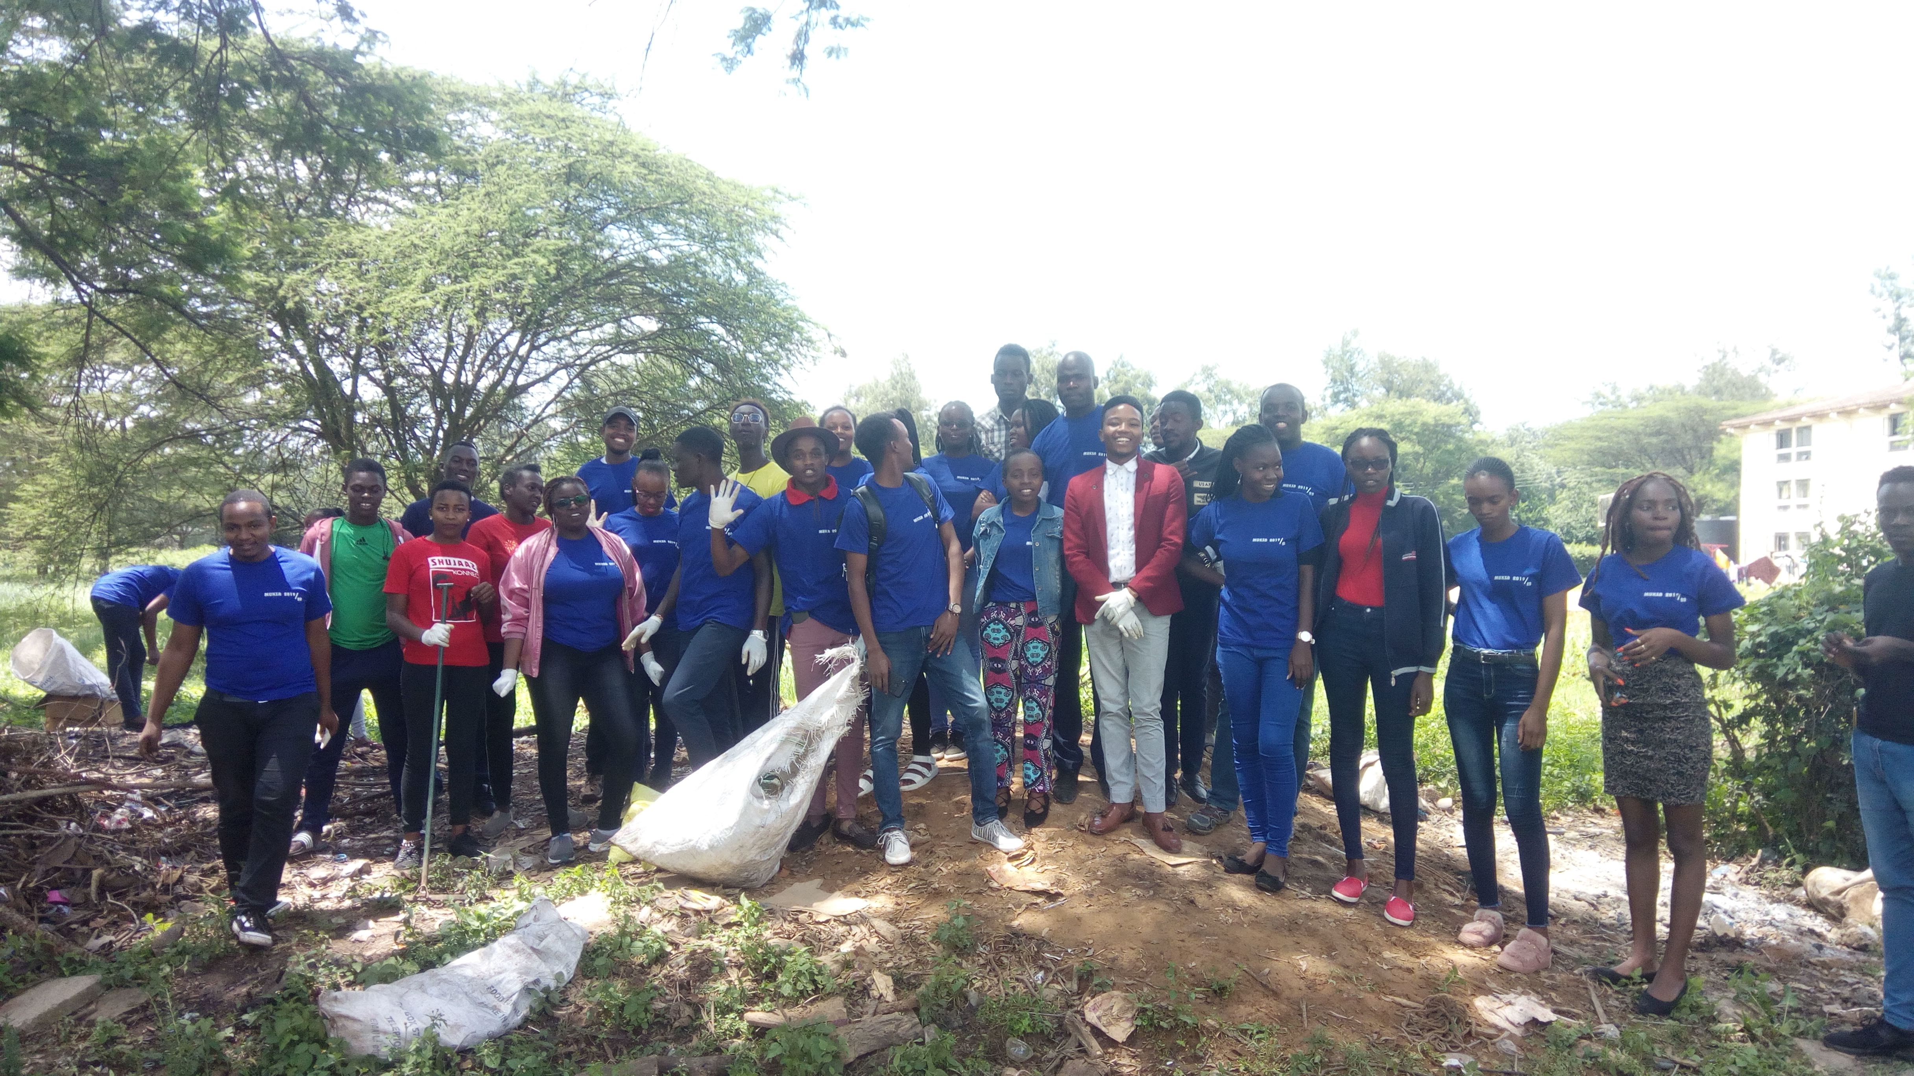

We met up with the Health and Environment club to share ideas on how we can create something great.

[#teamwork](https://www.wix.com/dashboard/6f655bb0-3c9d-4340-bdec-bec3057b3018/blog/published/search/.hash.teamwork?referralInfo=sidebar)